Supermarket Sales Analysis
Project Report | 500 transactions | January?July 2026

1. Executive Summary
This project analyzes 500 supermarket transactions to understand sales by product, category, branch, customer type, and payment method. Total sales are ?244,411.08 and the average rating is 3.99/5. Cheese leads product sales, Beverages leads category sales, and Branch C (Mumbai) has the highest branch sales. Findings support inventory planning, branch performance investigation, and customer-experience monitoring.

2. Problem Statement and Objectives
The objective is to convert transaction-level data into useful summaries: identify the highest-sales products and categories, best-performing branch, most-used payment method, average transaction differences by customer type, and overall customer rating.

3. Dataset
The source contains 500 rows and 13 fields: Invoice ID, Date, Branch, City, Customer Type, Gender, Product, Category, Quantity, Unit Price, Payment, Rating, and Sales. Dates range from January 01, 2026 to July 01, 2026. Currency is reported in Indian rupees, as specified in the project brief. Source spreadsheet: https://docs.google.com/spreadsheets/d/1QIX__4VObHFMEXnRM2xJyXmB5JAB2peHrJcQ41_U9TE/edit?usp=sharing.

4. Methodology
- Loaded the CSV with pandas and checked required fields, missing values, duplicate rows, and data types.
- Converted dates and numeric fields, then checked quantity, unit price, and rating ranges.
- Recomputed Sales = Quantity ? Unit Price; compared against source values within half a paisa and analyzed the recomputed values.
- Grouped sales, transaction counts, and units sold by product, category, branch/city, payment method, and customer type.
- Created comparative charts with Matplotlib and interpreted results descriptively.

5. Data Quality Results
Check | Result
Dimensions | 500 rows ? 13 columns
Missing values | 0
Duplicate rows | 0
Sales calculation | All source values match Quantity ? Unit Price within ?0.005
Rating range | 3.0?5.0 (valid 0?5 scale)

6. Results
Metric | Finding
Total sales | ?244,411.08
Average transaction sales | ?488.82
Top product by sales | Cheese ? ?27,906.30
Top category by sales | Beverages ? ?56,108.24
Top branch by sales | Branch C (Mumbai) ? ?72,469.45
Most-used payment method | UPI ? 127 transactions
Member average transaction | ?483.14 (296 transactions)
Normal average transaction | ?497.07 (204 transactions)
Average customer rating | 3.99 / 5

7. Visual Summary
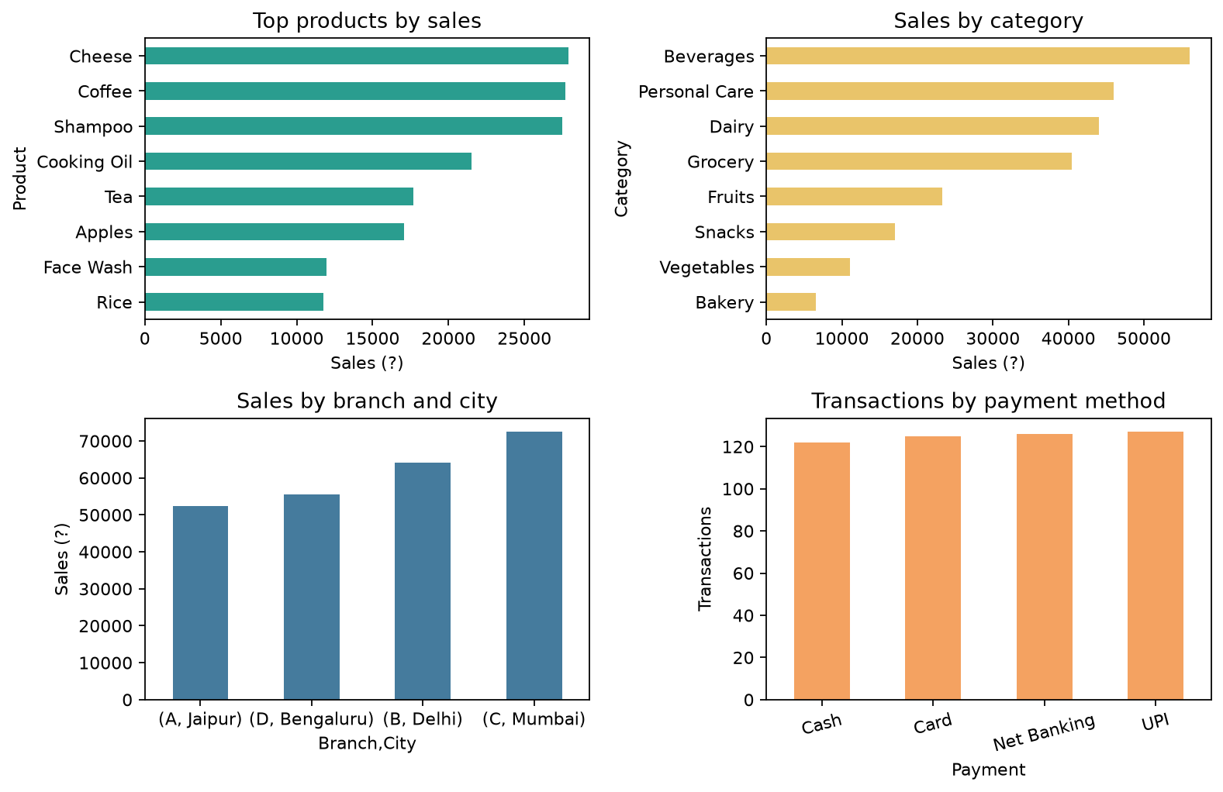

8. Business Recommendations
- Protect availability of Cheese and other high-sales products and assess category replenishment for Beverages. Check gross margin, shelf life, and stockout history before changing order quantities.
- Investigate Branch C (Mumbai) through comparisons of footfall, product mix, operating hours, local demand, promotions, and margins. Sales alone do not identify the cause of its lead.
- Continue supporting UPI while retaining all payment options: UPI has 127 transactions, close to Net Banking (126), Card (125), and Cash (122).
- Test targeted Member offers because observed Member average sales are below Normal customer sales; measure incremental spend rather than assuming a membership effect.
- Review feedback connected with low ratings and track rating trends after customer-service changes; current mean rating is 3.99/5.

9. Conclusion and Limitations
The sample shows meaningful differences in sales across products, categories, branches, and customer groups. It provides a starting point for inventory, payment, and service decisions. This is descriptive analysis of 500 transactions from a limited period; it does not establish causality and omits costs, margins, stockouts, promotions, customer identities, and longer-term customer value. Validate decisions with these additional measures and a broader time series.

10. Tools and Reproducibility
The companion Jupyter Notebook implements the workflow in Python using pandas and Matplotlib. Install packages from requirements.txt, place the CSV beside the notebook, and run all cells. If the local CSV is missing, the notebook attempts to read the Google Sheets CSV export, requiring internet access.

